**Appointment**

* Ascending and descending viewing of any column done
* Ability to limit the patient appointment done
* Manually adjust or limit the numbering e.g done
  + Myself can assign from new patient from 6 number and rest initial rows filled by admin manually
* Printing of appointment list each group and combined separately done
* Delete option of individual patient, specific dates and dates range done
* During appointment entry each word start with Capital letter automatically done
* New appointment Save on click of save button if double click it make double entry kindly correct it. It is save by enter button too. done
* On entry of appointment following problem occurred done

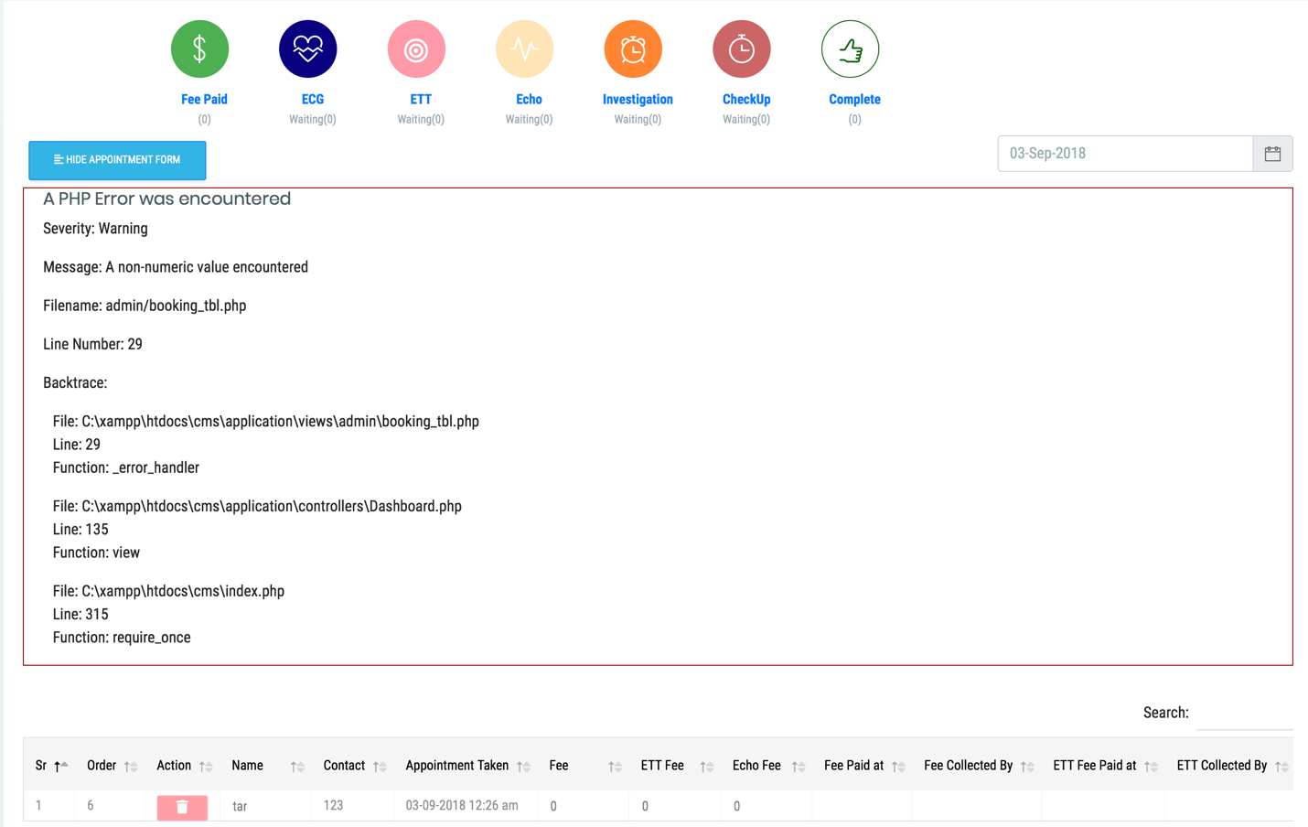

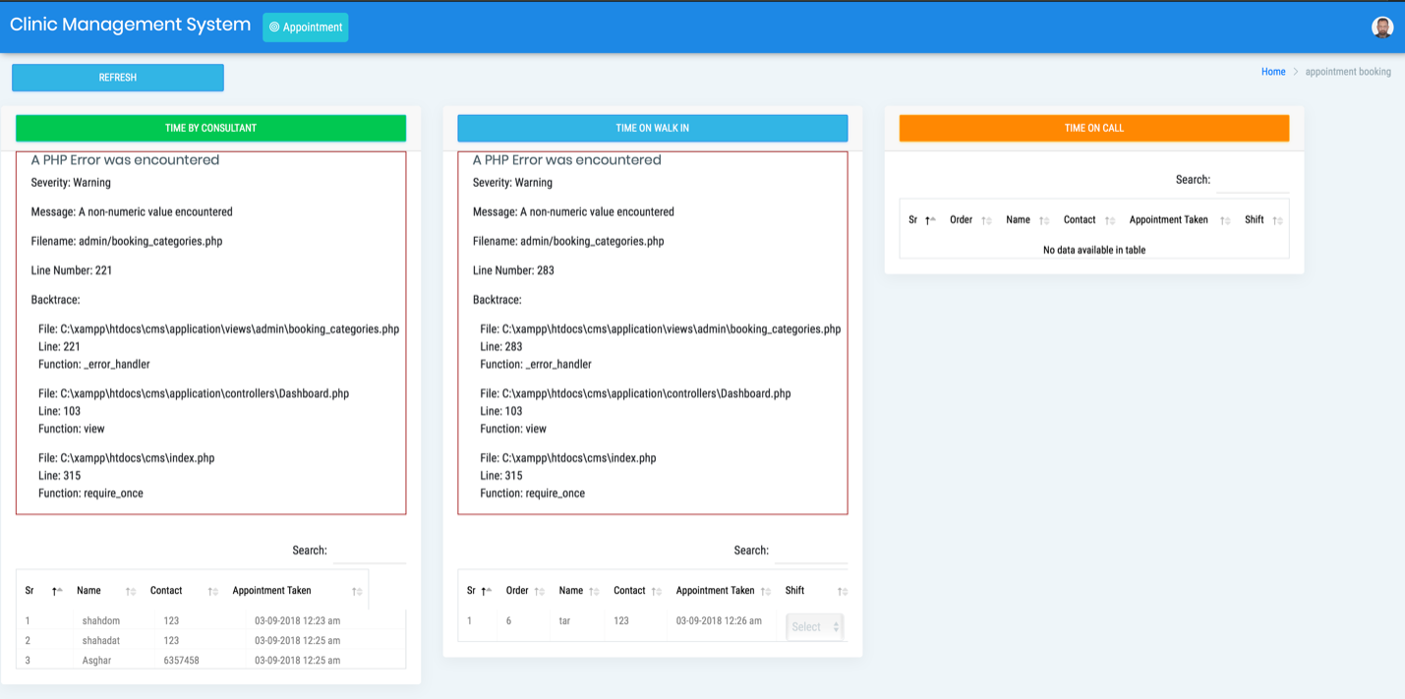

In general

* Enter should dark to visible -it is now fake correct it please
* Edit of permission for registered user please or give list of registered user along sidebar